Sign-up & Enrollement for Virtual Workshops 2023

PEP/PYP, PAI/MYP, DP, IB ED & LEAD WORKSHOPS, Categories 1, 2 y 3 will take place May 22,23 & 24TH.

GENERAL INFORMATION:

- 2024 Workshops
Santiago College – Santiago-Chile
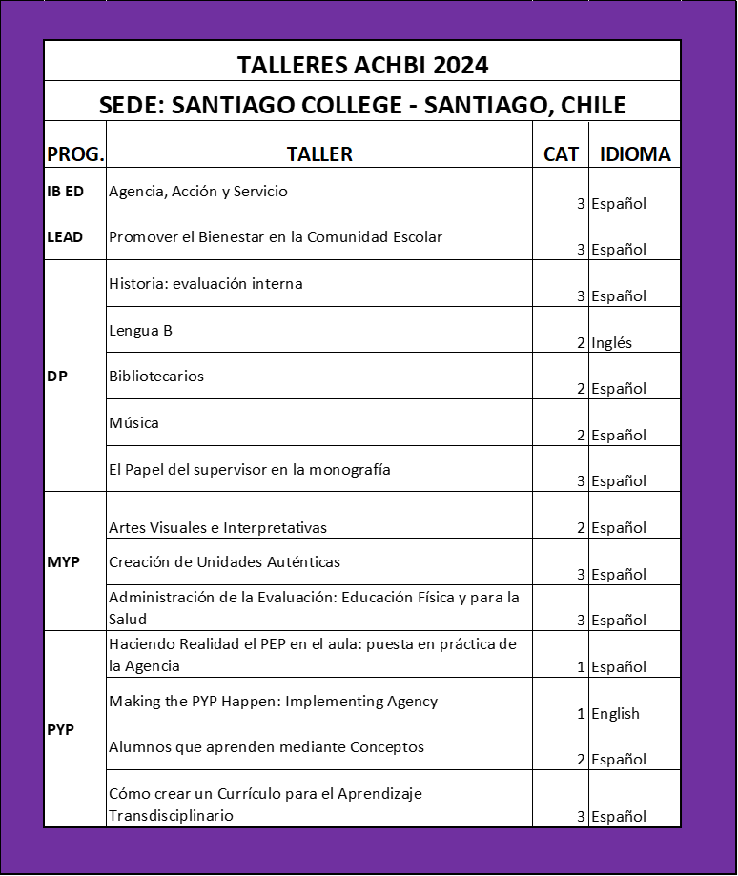

- TOTAL COST OF THE WORKSHOPS:
  - REGISTRATION BEFORE MARCH 25th
$450.000 - Chilean Pesos for each participant from member schools, members of ACHBI and other institutions on agreement – US$ 511 for foreign participants.
$ 500.000 - Chilean Pesos for each participants from school not affiliated with ACHBI - US$ 568 for foreign participants.
  - REGISTRATION AFTER MARCH 25th
$ 470.000 - Chilean Pesos for each participant from member schools, members of ACHBI and other institutions on agreement - US$ 531 for foreign participants.
$ 520.000 - Chilean Pesos for each participants from school not affiliated with ACHBI - US$ 588 for foreign participants.

Payment for the workshops may be done by bank transfer or via deposit to the following account:

Name: Asociación Chilena del Bachillerato Internacional
RUT: 65.629.810-3
Banco: BICE - Sucursal La Dehesa
N° de cuenta en pesos chilenos: 14-74059-7
N° de cuenta en dólares: 013-14-00311-6

Credit cards may be used via Transbank.

- For this event, “franquicia SENCE” will not be used. ACHBI will Invoice schools for each participant and the schools should make the transfer and/or deposit as indicated in Point 2 above, either in pesos for Chilean schools or in dollars for foreign schools.

- Once the transfer or payment is made, please send a copy of the receipt or bank transfer notification, clearly indicating the sender, to the following email address: karla@achbi.cl.

- Foreign registrants should deposit a total de US$540 0r US$570 to ACHBI’s account, adding the amount for any fees or taxes that may apply.

- ACHBI will provide an Invoice or a receipt showing the payment made in accordance with Chilean law. The payment receipt will be nominated in Chilean Pesos and the description field shown the corresponding dollar amount. Foreign schools are requested to submit the following details for invoicing purposes: official name of the institution, address, school registration number (RUC, RUT, other) and request any other documentation they may need for their school or country for accounting purposes.

- The final date for enrollment will be May 10th, 2024.

- Following enrollment, any changes in workshops should be discussed and coordinated in advance with Karla Frauenberg.

- In the event that a program or course is not delivered due to reasons attributable to ACHBI and/or IB, a full and immediate refund will be processed for amounts paid or transferred to ACHBI’s account.

- If any registrants enrolled in a workshop decide not to participate for personal reasons or circumstances, not imputed to the institutionn, no funds paid will be returned except in extraordinary cases, to be determined on their merits by ACHBI. Not participatiing in the workshop is not considered of sufficient merit in and of itself for a refund.

- Unless a minimum of 10 participants enroll for any given workshop, that workshop may be canceled. Timely notification in such cases will be provided along with the corresponding full refund.

- Please complete the registration form in the workshop of your choice. You can find it in www.achbi.cl

- If you need to contact ACHBI, you can call (+56 9) 93315395 or send an e-mail.

- If you need more information about hotels, transfer or other reservations, you can request it at karla@achbi.cl
Sincerely,

Karla Frauenberg D.
Executive Director

